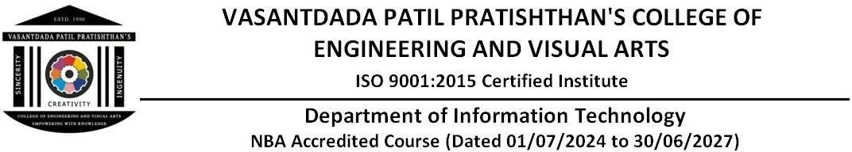

# Experiment no. 5

**Aim :** To understand terraform cycle, core concepts and terminologies and install it on Linux machine.

# Theory :

**Terraform lifecycle**

The lifecycle of a resource managed by Terraform has three stages: Apply, Update, and Destroy. The lifecycle meta-argument allows users to control these stages.

# Terraform CLI

The Terraform Command Line Interface (CLI) is the primary tool for interacting with Terraform'scode.

# Terraform core workflow

The core workflow of Terraform consists of the following stages:

init: Initializes the local Terraform environment

plan: Compares the Terraform state with the cloud state, and creates an execution plan apply: Executes the plan to change the deployment

destroy: Removes all resources defined in the Terraform configuration

# Core concepts

Some other core concepts of Terraform include:

Variables: Key-value pairs that allow customization

Provider: A plugin that allows users to interact with APIs of a service

Module: A folder containing Terraform templates that define configurationsState: Cached information about the infrastructure managed by Terraform Resources: A block of one or more infrastructure objects Data Source: Returns information on external objects to Terraform

Output Values: Return values of a Terraform module that can be used by other configurations

# Output :

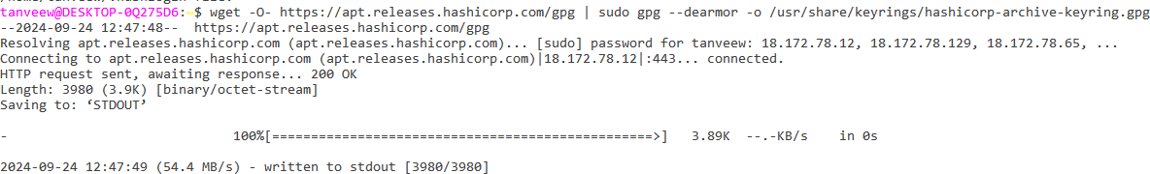

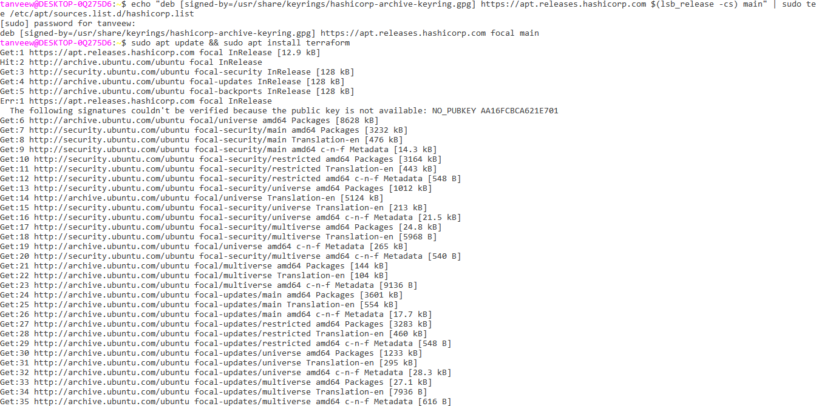

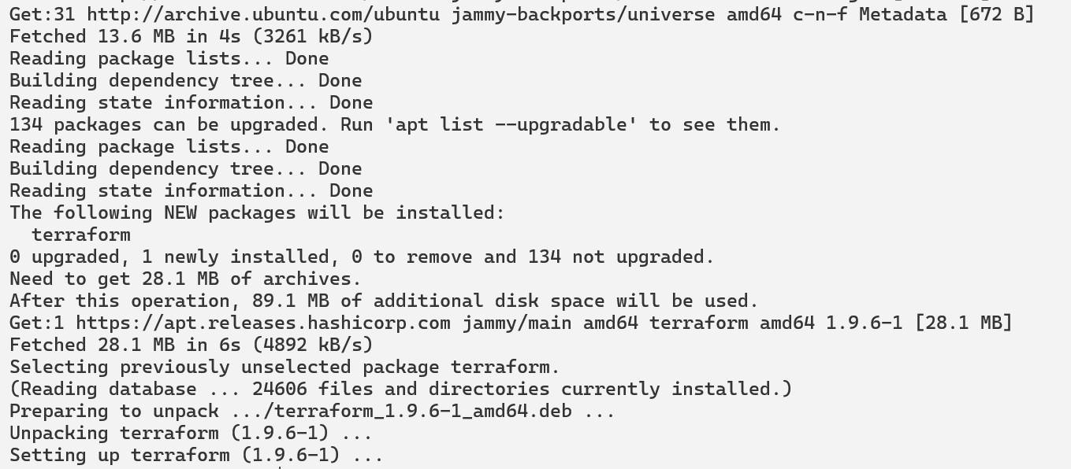

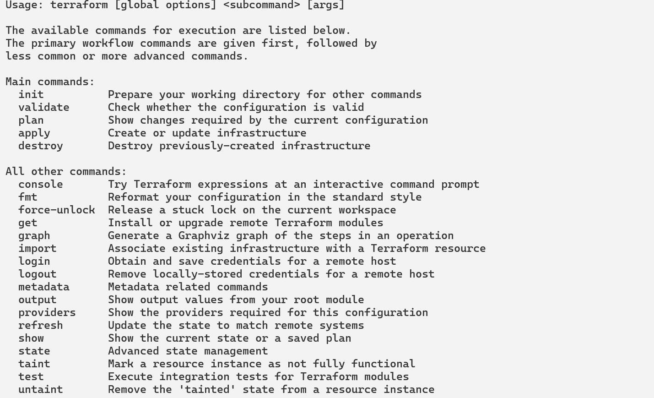

* **Conclusion :** Hence we have understand terraform cycle, core concepts and terminologies and successfully install it on Linux machine.